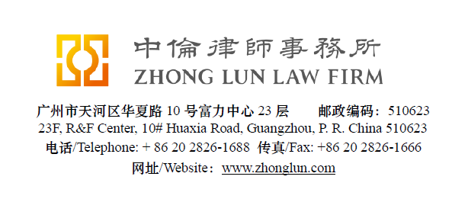

Invoice / 收款通知书

|  |  |  |  |
| --- | --- | --- | --- |
| **Date**  **日期** | 28/07/2019 | **ZL Invoice Reference[1]**  **中伦收款通知编号** | 049139-0001/057 |
| **Client**  **客户** | | **BP Singapore Pte. Limited.**  **Attn: Nikki CHAN**  7 Straits View,  Marina One East Tower,  #26-01, Singapore 018936 | |
| **Subject Matter**  **事项** | **General** | **Service Period**  **服务期限** | June 2019 |
| **Legal Fee**  **律师费** | USD 1402.30 | **Reimbursement**  **报销费用** |  |
| **Sum Now Due[2]**  **总应付款** | USD 1402.30 | | |

Please make the payment to the banks account as follows:

请将上述款项付至下列账户：

|  |  |  |  |
| --- | --- | --- | --- |
| **Account Number**  **账号** | 1209 0403 9310 502 | Swift Code **银行代码** | CMBCCNBS131 |
| **Account Name[3]**  **账户名称** | Beijing Zhong Lun Law Firm Guangzhou Office  北京市中伦（广州）律师事务所 | | |
| **Bank Name**  **开户行** | China Merchants Bank, Guangzhou Branch, R&F Center Subbranch  招商银行广州分行富力中心支行 | | |
| **Address**  **地址** | 2/28F R&F Center, 10 Huaxia Road, Guangzhou, China  广州市华夏路10号富力中心2/28楼 | | |

**Zhong Lun Law Firm 中伦律师事务所**

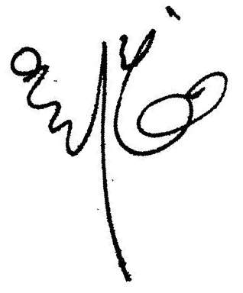

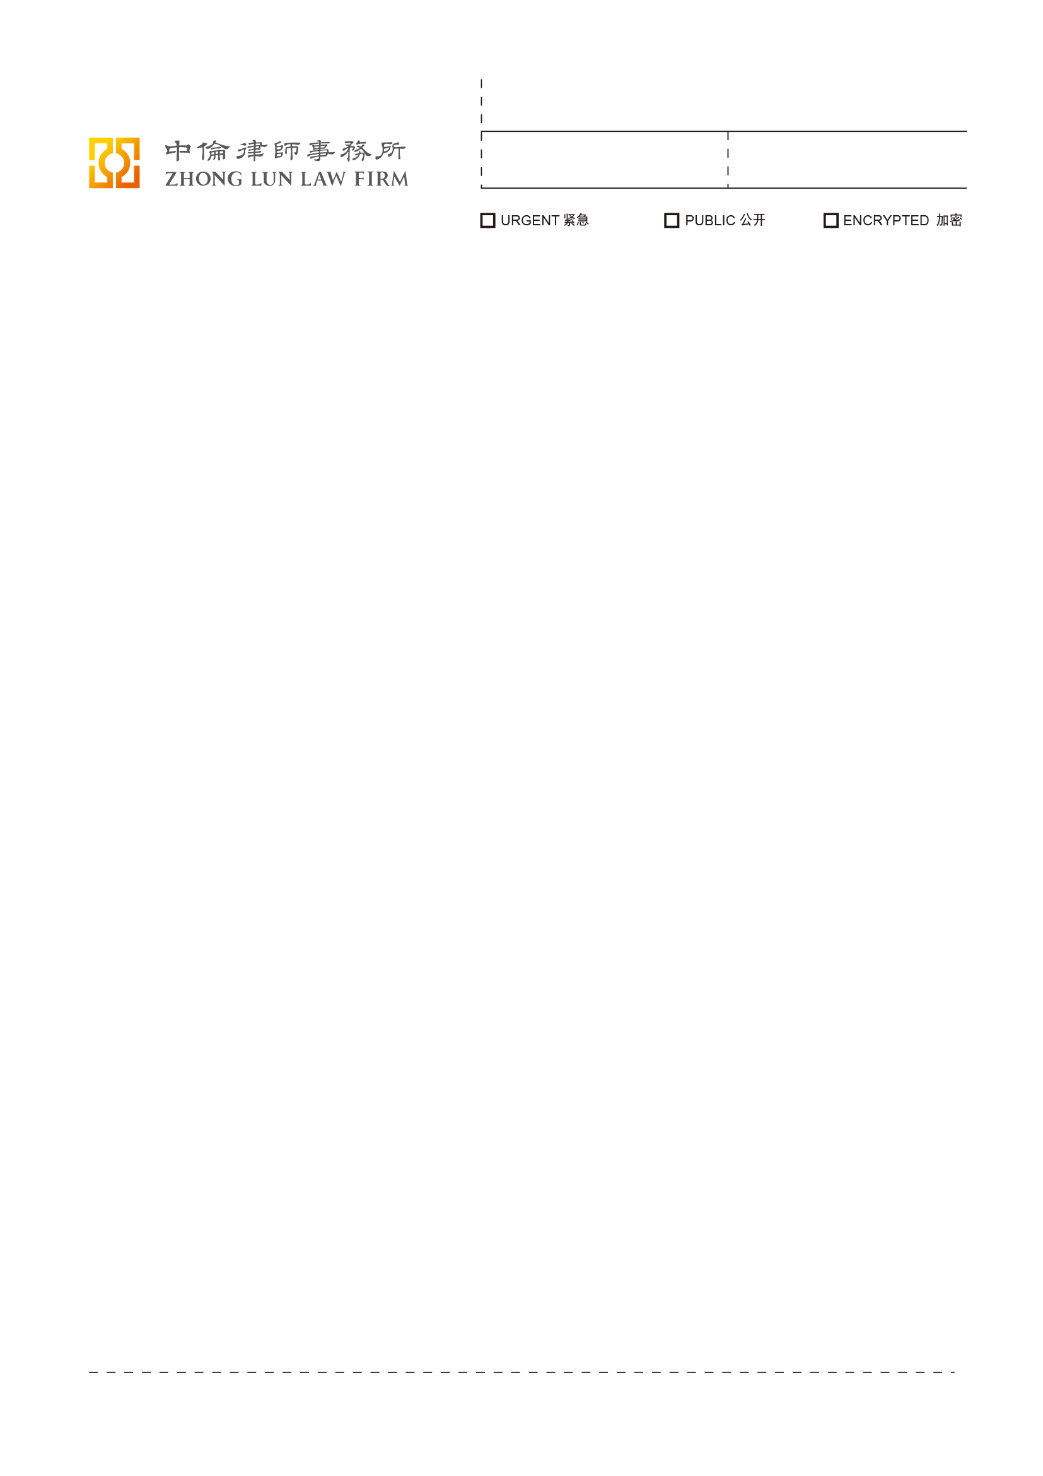 **Charge Details/收费明细**

To our Professional Charges for our service rendered in respect of the following:

中伦律师事务所就如下事宜提供了专业服务：

|  |  |  |
| --- | --- | --- |
|  | Service Provided已提供之服务 | **Cost (RMB)**  **费用（人民币）** |
|  |  |  |
|  | Translating the Delivery Confirmation Template for Hongrun revised. | 874.50 |
|  |  |  |
|  | Translating the Delivery Confirmation Template for Lianhong revised. | 874.50 |
|  |  |  |
|  | Translating the Hengli Mandate Letter (7 June 2019). | 2,332 |
|  |  |  |
| 4. | Proofreading the translation of the Hongrun-spot storage contract-2019-v6. | 5,538.50 |
|  |  |  |
|  | **Totals/合计:** | **9,619.50** |
|  |  |  |
|  | **In USD:** | **1,402.30** |

1. **Please kindly indicate the ZL Invoice Reference number on your bank processing document and provide us a copy of the bank confirmation for the payment. /请在银行付款单据上标明中伦收款通知编号，并向我方提供相关银行确认书。**
2. **Please pay equivalent foreign currency if a USD account is not available. /若未能支付美元，请支付等值外币。**
3. **Please indicate the FULL name in the bank advice and state the FULL name at the remark or note section on the bank advice./ 请在银行付款单据上列明全称并在汇款附言或备注栏填入收款人全称。**